

**Sensor Integration Module**

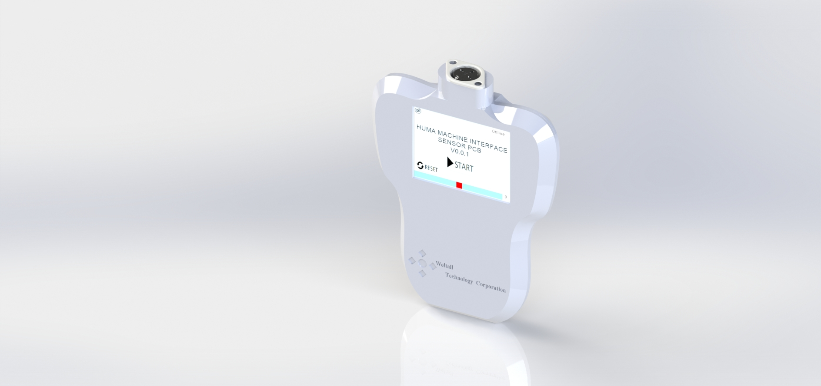

****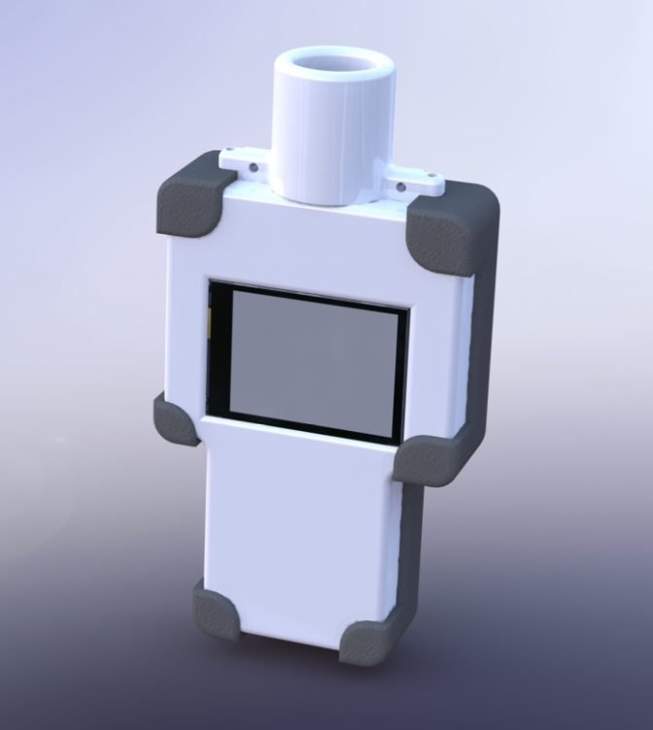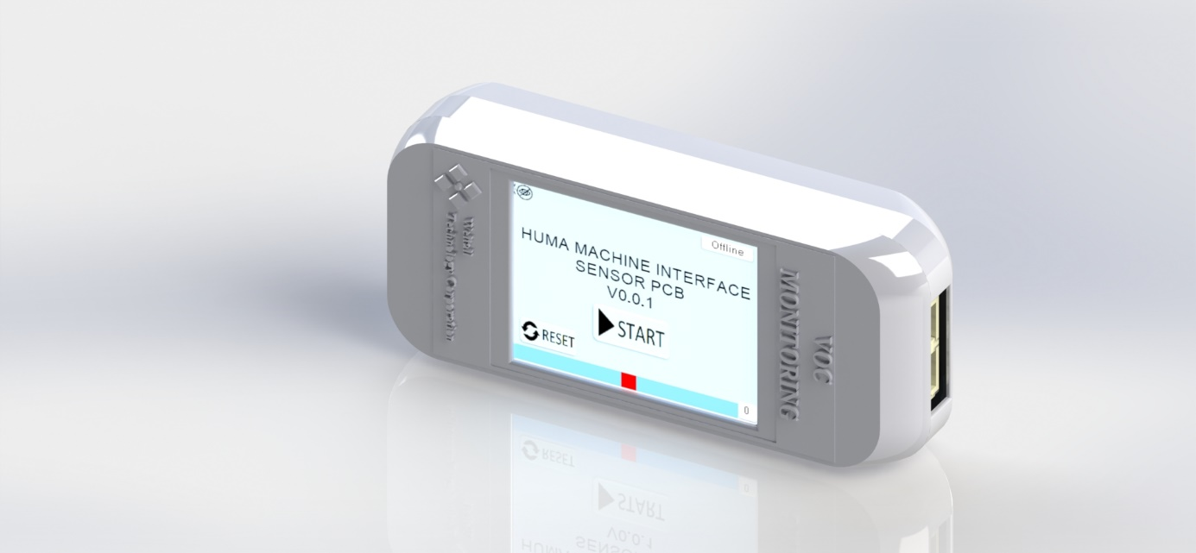

Table of Contents

Table of Contents 2

Table of Figures 3

**Chapter 1 Introduction** 6

**Chapter 2 Electrical Diagrams** 8

Voltage Control 8

Microcontroller Unit 8

Digital/Analog Input 10

**Chapter 3 PCB Elements** 12

**Chapter 4 Hardware Connection** 19

**Chapter 5 Touch Panel** 21

Page 0: 21

Page 1 22

Page 2 23

Page 3 24

Page 4 25

Page 5 26

Page 6 27

Page 7 28

Page 8 29

Page 9 30

Page 10 31

Page 11 32

Page 12 33

Page 13 34

Page 14 35

**Chapter 6 Settings** 36

**Chapter 7 Attachment** 41

Table of Figures

Figure 1.1 Gas Detection Gas Watch Model 6

Figure 1.2 piD Sensor Tehcnologis 7

Figure 1.3 Nextion Display 7

Figure 2.1 Voltage Control 8

Figure 2.2 ATmega2560AU 9

Figure 2.3 Low Power bidirectional isolators I2C 9

Figure 2.4 Analog to Digital converters ADS1115 10

Figure 2.5 Analog Digital Input 10

Figure 2.6 Communication Port 11

Figure 3.1 PCB Eagle Design 12

Figure 3.2 3D Visualizer Mode Eagle SolidWorks 13

Figure 3.33D Visualizer Mode Eagle solidworks 13

Figure 3.4 PCB Result Eagle Solid Works 14

Figure 3.5 PCB Result 14

Figure 3.6 PCB front view 15

Figure 3.7 PCB side view 16

Figure 3.8 PCB Side wide Communication Port 17

Figure 3.9 PCB side view 18

Figure 4.1 Disassembly Prototype 19

Figure 4.2 Box PCB 20

Figure 5.1 Page 0 Nextion Editor 21

Figure 5.2 Page 1 Nextion Editor 22

Figure 5.3 Page 2 Nextion Editor 23

Figure 5.4 Page 3 Nextion Editor 24

Figure 5.5 Page 4 Nextion Editor 25

Figure 5.6 Page 5 Nextion Editor 26

Figure 5.7 Page 6 Nextion Editor 27

Figure 5.8 Page 7 Nextion Editor 28

Figure 5.9 Page 8 Nextion Editor 29

Figure 5.10 Page 9 Nextion Editor 30

Figure 5.11 Page 10 Nextion Editor 31

Figure 5.12 Page 11 Nextion Editor 32

Figure 5.13 Page 12 Nextion Editor 33

Figure 5.14 Page 13 Nextion Editor 34

Figure 5.15 Page 14 Nextion Editor 35

Figure 6.1 Nextion Screen Page 0 36

Figure 6.2 Set Min.Voltage of sensor 36

Figure 6.3 Set minimal value 37

Figure 6.4 Set minimal value visualization 37

Figure 6.5 Set Maximal value 38

Figure 6.6 Set Maximal value 38

Figure 6.7 The new value after mapping 39

Figure 6.8 DHT SENSOR 39

Figure 7.1 IO PCB VERSION 1 41

Figure 7.2 Wifi SD Card PCB Version 1 41

Figure 7.3 Prototype V2 42

Figure 7.4 Holder Prototype V2 42

Figure 7.5 Disassembly Prototype v2 43

Figure 7.6 piD Sensor Holder 43

List of Tables

Table 1 HARDWARE PCB 15

Table 2 DHT11 SENSOR AND VOC SENSOR 16

Table 3 Side Input 16

Table 4 PORT 1 and PORT 2 17

Table 5 Input pin out 18

Table 6 Disassembly Prototype Parts 19

Table 7 PCB Holder 20

Table 8 Description of HMI of Page 0 21

Table 9 Description of HMI of Page 1 22

Table 10 Description of HMI of Page 2 23

Table 11 Description of HMI of Page 3 24

Table 12 Description of HMI of Page 4 25

Table 13 Description of HMI of Page 5 26

Table 14 Description of HMI of Page 6 27

Table 15 Description of HMI of Page 7 28

Table 16 Description of HMI of Page 8 29

Table 17 Description of HMI of Page 9 30

Table 18 Description of HMI of Page 10 31

Table 19 Description of HMI of Page 11 32

Table 20 Description of HMI of Page 12 33

Table 21 Description of HMI of Page 13 34

Table 22 Description of HMI of Page 14 35

# **Introduction**

Several Gas detectors have been designed to solve a mean issue, such as CO2 measurement, H2S measurement or simply moisture. The entire spectrum of Gas Detector has been reduced due to its functionality, therefore the development of an innovative way to measure the VOC is proposed in this project.

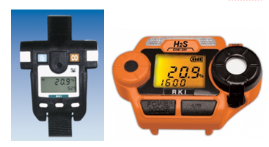

Figure 1.1 Gas Detection Gas Watch Model

Sensor assembly and case designs are going to fill the requirements, which the other devices cannot work due to their limitations, specifications and environment work as well.

The development of the sensor integration module project was carried out through several phases or sub process. The goal of the first prototype is to be the base for future researches and improves.

Within the area of sensor and devices the currently equipment just provide a normal information but they don’t have any innovative application working related to the new technologies.

As sensor testing we are using a piD TECH Photoionization Sensor, Typical photoionization detectors measure volatile organic compounds and other gases in concentrations from sub parts per billion to 10 000 parts per million (ppm). The photoionization detector is an efficient and inexpensive detector for many gas and vapor analytes. PIDs produce instantaneous readings, operate continuously, and are commonly used as detectors for gas chromatography or as hand-held portable instruments. Hand-held, battery-operated versions are widely used in military, industrial, and confined working facilities for health and safety

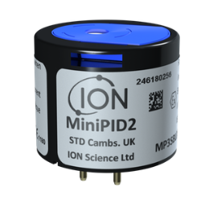

Figure 1.2 piD Sensor Tehcnologis

Sensor module must provide a solution for the sensing and control, this prototype contains several options for handling input and output voltages, these applications are going to explain in the next chapters.

The equipment is composed of a display which allows us to set the parameter of detection and to visualize the data. This handbook will show each setting to set a best performance of the sensor.

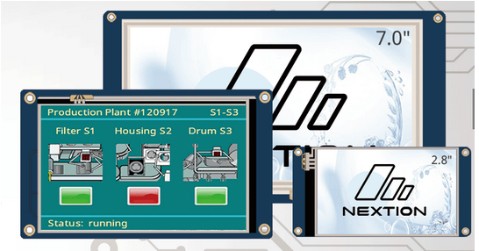

Figure 1.3 Nextion Display

In order to describe the functionality of the prototype it is going to be detailed in electrical, mechanical and software items.

# **Electrical Diagrams**

The Electrical Diagram shows the entire design of the control board, in order to understand every function is divided by three parts:

## Voltage Control

In this diagram we can find the voltage source, this input will supply 5v continuous. Three important part in this scheme:

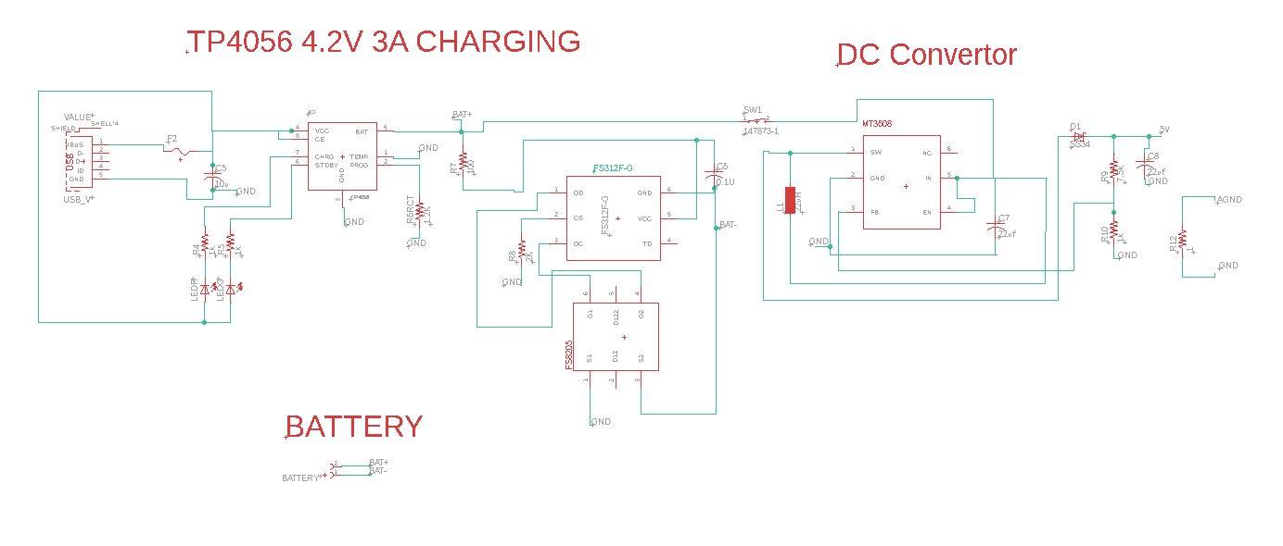

Figure 2.1 Voltage Control

Voltage input of 3.7 ~ 5 volts, using a micro USB as connector. The second part is the charging of battery based on the TP4056 chip, is a complete constant-current/constant-voltage linear charger for single cell lithium-ion batteries. Its SOP package and low external component count make the TP4056 ideally suited for portable applications. The final stage is the MT3608, 2V to 24V input voltage with output boost 5V.

## Microcontroller Unit

The simple control is based on ATmega 2560AU, which will contain the firmware of the system.

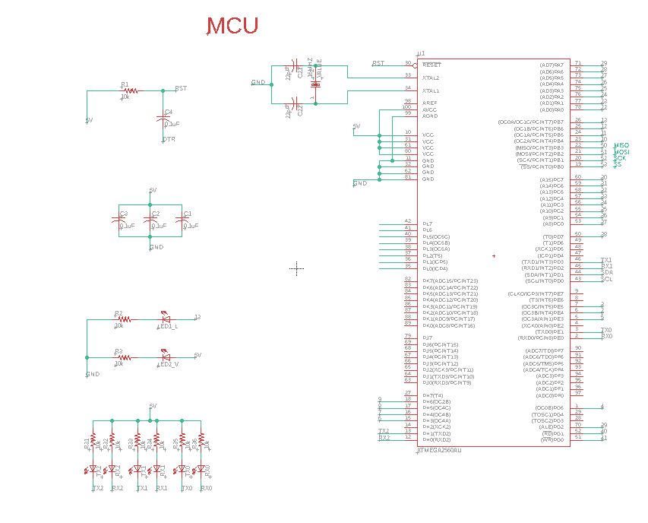

Figure 2.2 ATmega2560AU

We use three port of serial communication to link with the extra shield. I2C and SPI communication as well. A key point in this item is the ideal conditioning of the signal which is carried out through ISO1541.

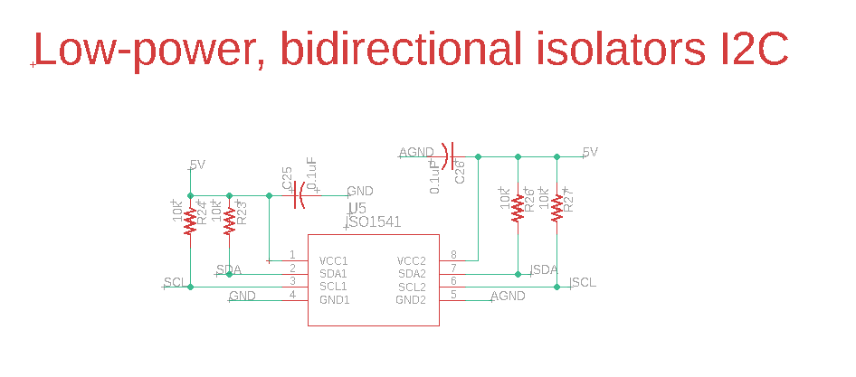

Figure 2.3 Low Power bidirectional isolators I2C

## Digital/Analog Input

To have a wide range of voltage detection an ADS1115 is used, this device is precision, low-power, 16-bit, I2C-compatible, analog-to-digital converters (ADCs).

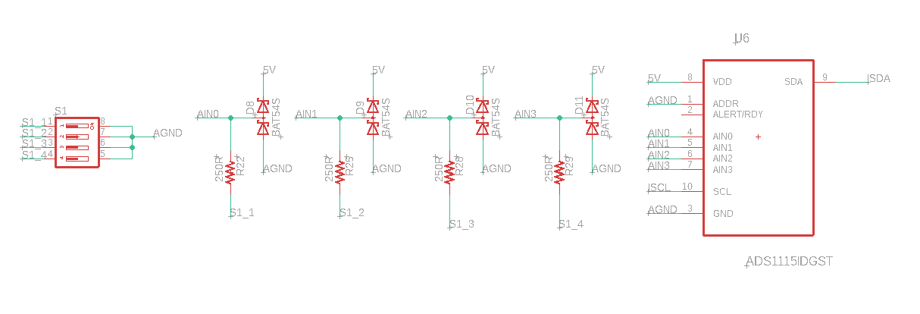

Figure 2.4 Analog to Digital converters ADS1115

The rest of inputs are the piD sensor, dht11/22, extra I2C and extra analog input, for the temperature humidity sensor the dht11/22 use a digital input for communication.

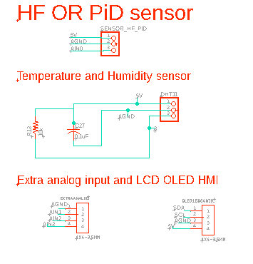

Figure 2.5 Analog Digital Input

The protocol communication is detailed in the next terminals.

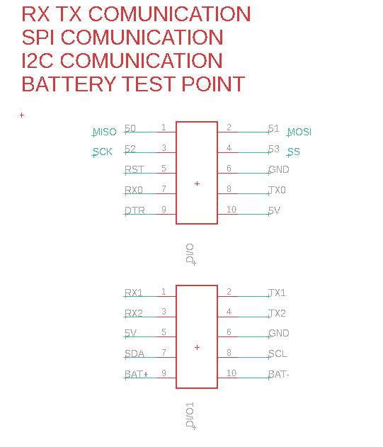

Figure 2.6 Communication Port

Through this terminal we can upload the firmware, and check the correct functionality moreover it is the base for the extra shield.

# **PCB Elements**

The PCB was designed by Eagle student version, the final size of our board is the 100x40 mm

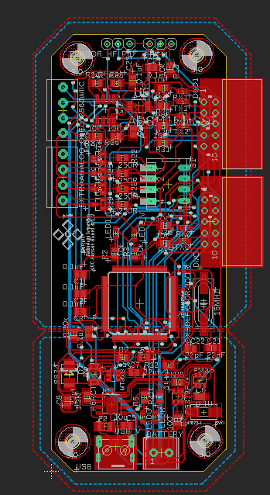

Figure 3.1 PCB Eagle Design

Using the 3D visualizer mode, we can check the real size out.

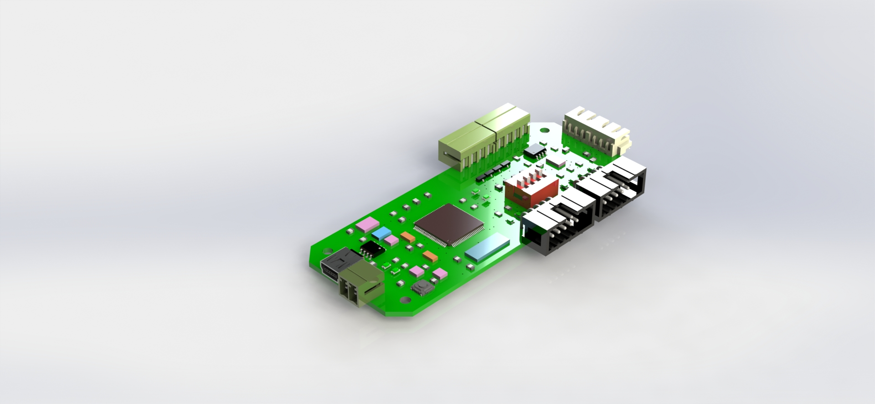

Figure 3.2 3D Visualizer Mode Eagle SolidWorks

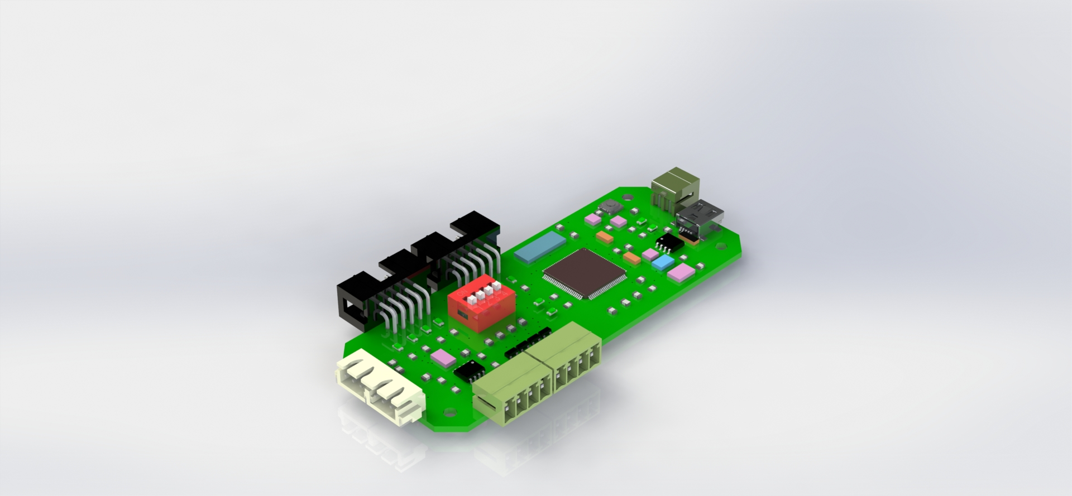

Figure 3.33D Visualizer Mode Eagle solidworks

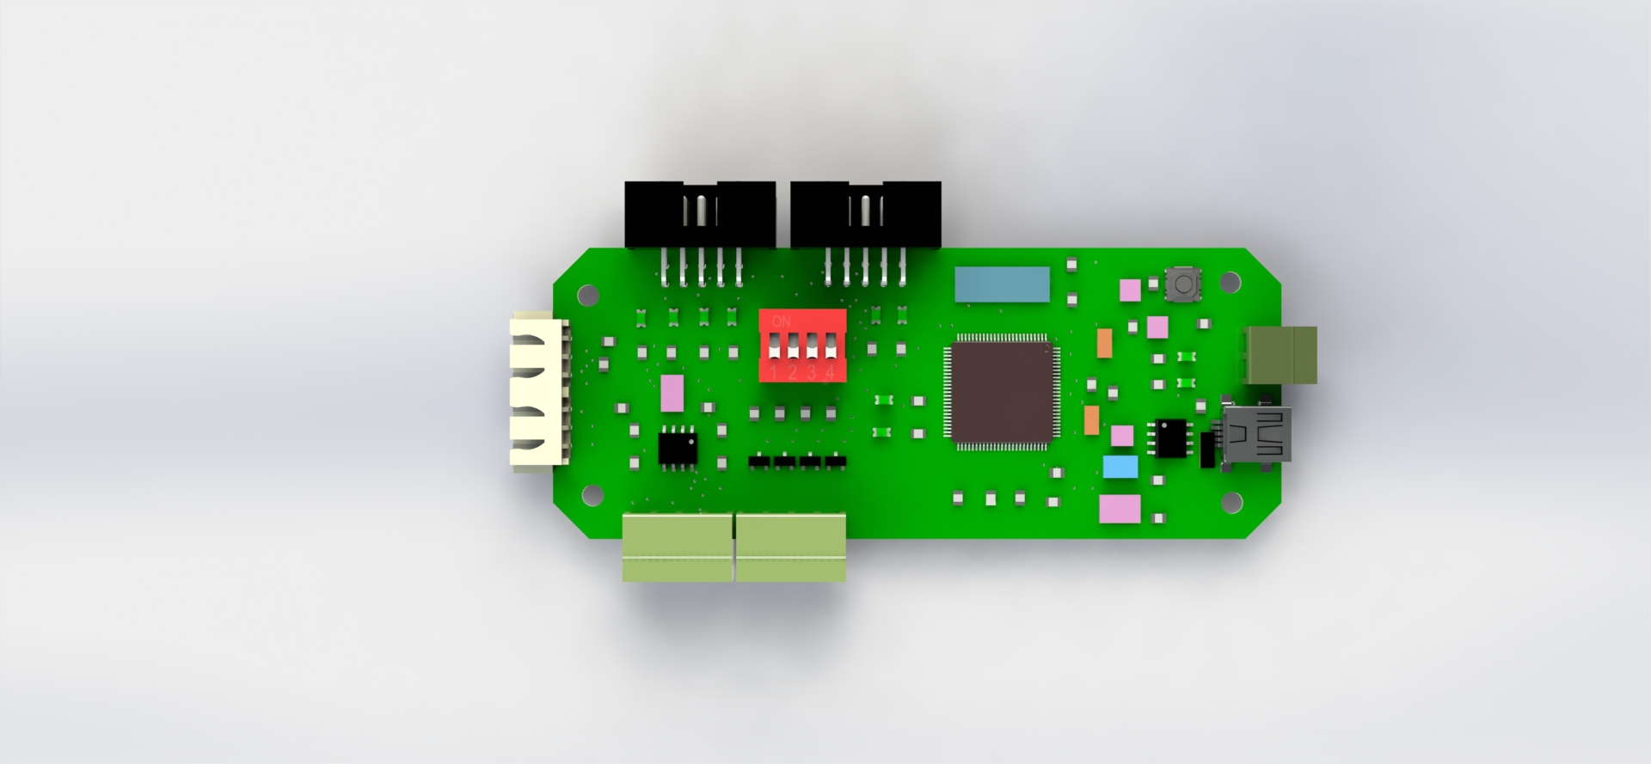

11

10

9

8

7

6

5

4

3

2

1

Figure 3.4 PCB Result Eagle Solid Works

3

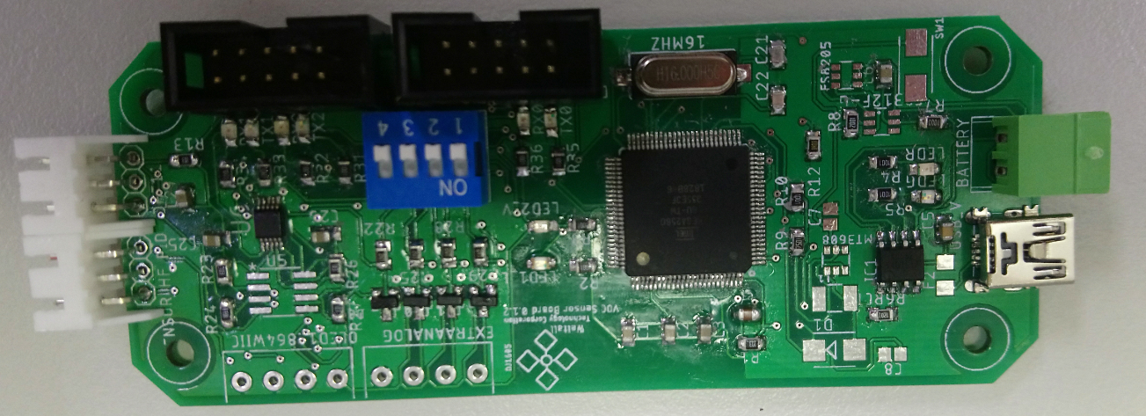

10

6

7

5

4

11

1

2

8

9

Figure 3.5 PCB Result

Table 1 HARDWARE PCB

|  |  |  |  |  |  |
| --- | --- | --- | --- | --- | --- |
| 1 | 5 volts input micro USB | 5 | I2C Communication/SPI | 9 | PORT Communication |
| 2 | Battery 3.7 5 v input | 6 | VOC Sensor Input | 10 | Set Voltage / Current |
| 3 | Reset | 7 | DHT11/DHT22 Sensor Input | 11 | MCU ATmega2560 |
| 4 | Analog Input V/I | 8 | PORT Communication |  |  |

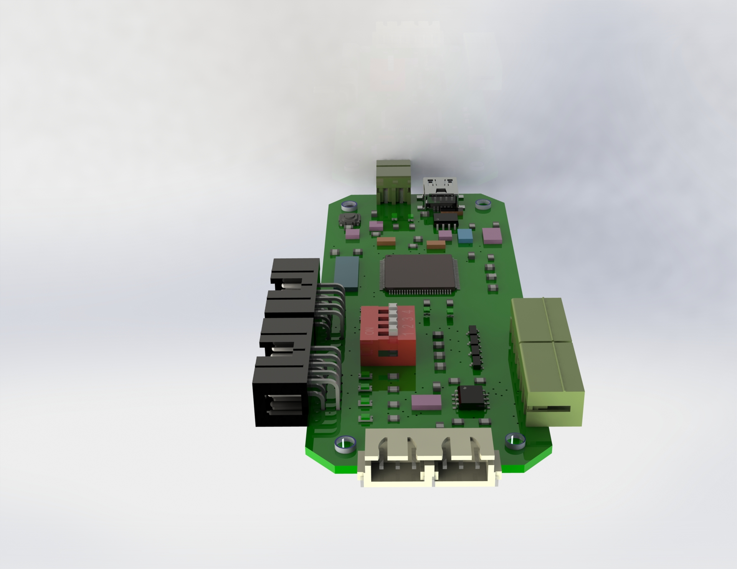

1

2

3

1

2

3

B

A

Figure 3.6 PCB front view

Table 2 DHT11 SENSOR AND VOC SENSOR

|  |  |  |  |
| --- | --- | --- | --- |
| A | DHT11/DHT22 SENSOR  DIGITAL INPUT (3) | 1 | VCC 5V |
| 2 | GND |
| 3 | AIN0 VOC SENSOR |
| B | VOC SENSOR  ANALOG INPUT (0) | 1 | DIN3 DHT11/22 |
| 2 | GND |
| 3 | VCC 5V |

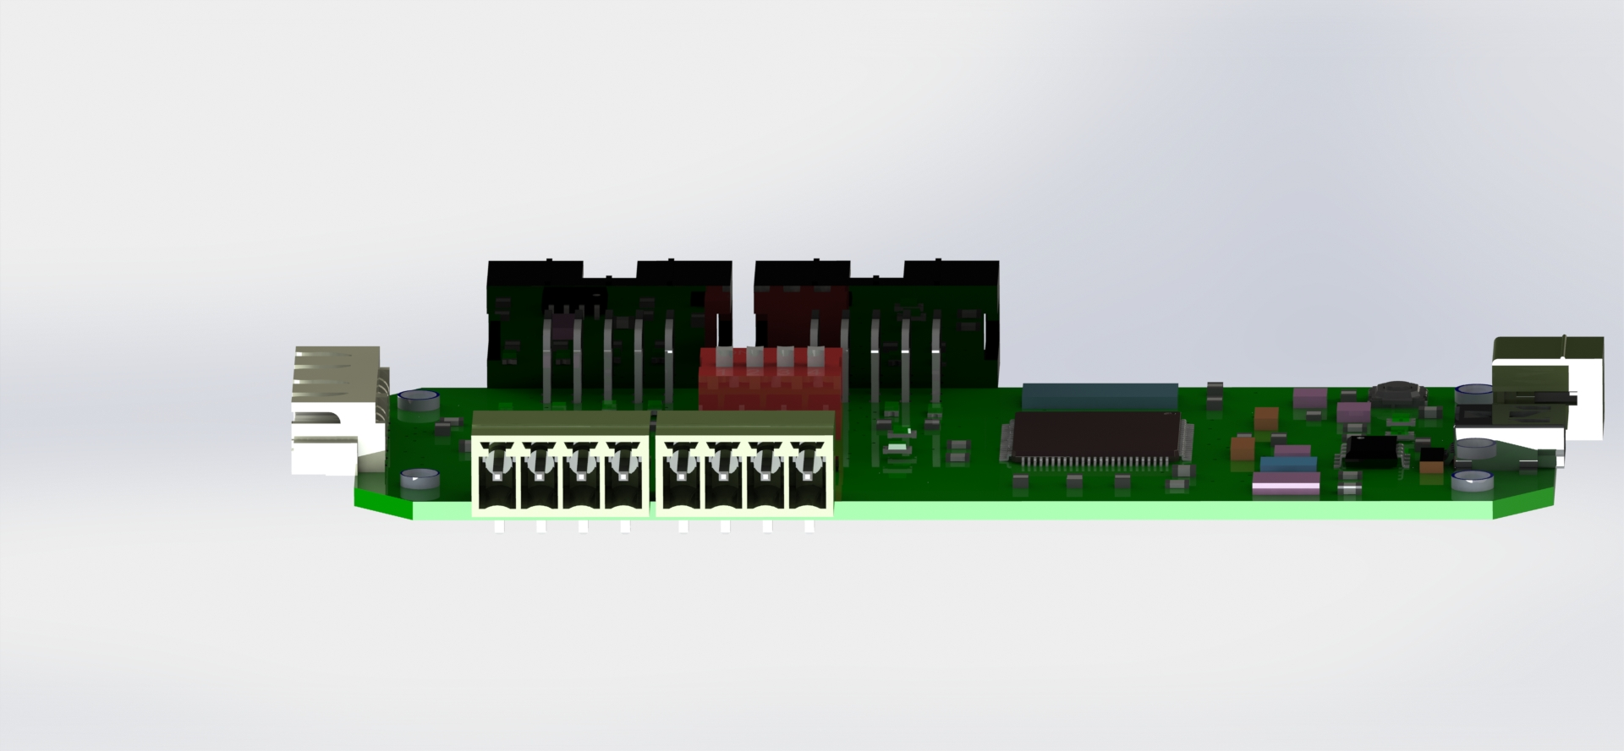

1

2

3

4

4

3

2

1

C

D

Figure 3.7 PCB side view

Table 3 Side Input

|  |  |  |  |
| --- | --- | --- | --- |
| C | OLED LCD  I2C SPI | 1 | SDA |
| 2 | SCL |
| 3 | GND |
| 4 | 5V Vcc |
| D | EXTRA ANALOG INPUT | 1 | GND |
| 2 | AIN1 |
| 3 | AIN2 |
| 4 | AIN3 |

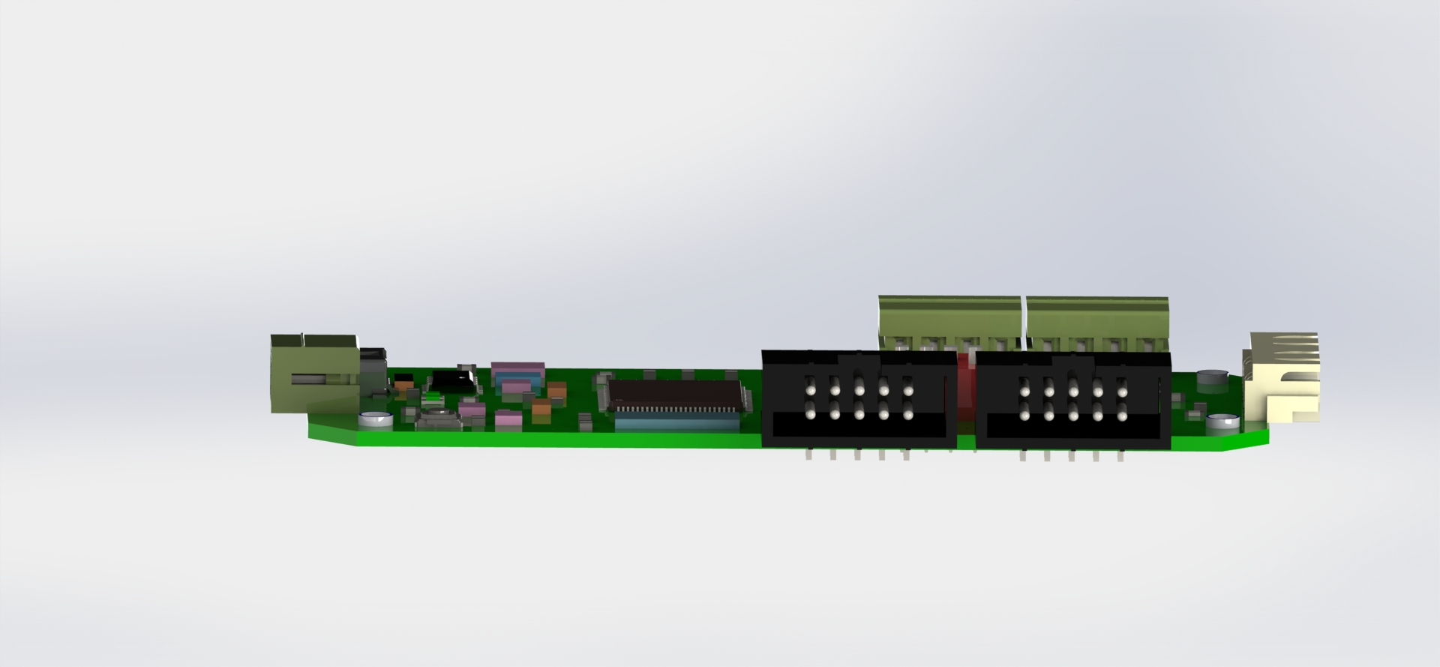

2

2

10

8

6

4

1

3

5

7

9

4

6

8

10

3

1

7

9

5

E

F

Figure 3.8 PCB Side wide Communication Port

Table 4 PORT 1 and PORT 2

|  |  |  |  |
| --- | --- | --- | --- |
| E | PORT Comunication 1 | 1 | 5V Vcc |
| 2 | DTR |
| 3 | TX0 |
| 4 | RX0 |
| 5 | GND |
| 6 | RST |
| 7 | 53 SS |
| 8 | 52 SCK |
| 9 | 51 MOSI |
| 10 | 50 MISO |
| F | PORT Comunication 2 | 1 | BAT - |
| 2 | BAT + |
| 3 | SCL |
| 4 | SDA |
| 5 | GND |
| 6 | 5V Vcc |
| 7 | TX2 |
| 8 | RX2 |
| 9 | TX1 |
| 10 | RX1 |

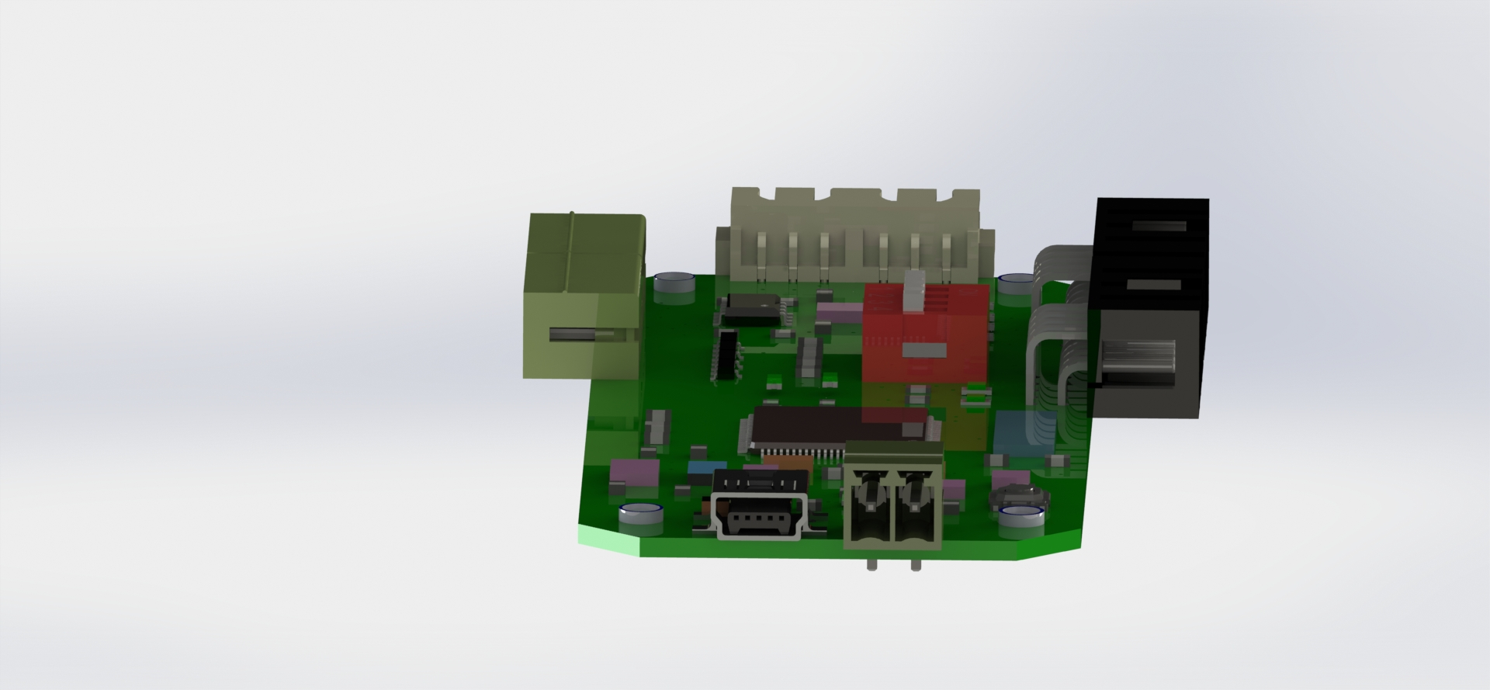

2

1

H

G

Figure 3.9 PCB side view

Table 5 Input pin out

|  |  |  |  |
| --- | --- | --- | --- |
| G | MICRO USB CHARGER | 1 | 3.7 ~ 5 Vcc |
| H | BATTERY SOURCE | 1 | Negative Pole Battery |
| 2 | Positive Pole Battery |

# **Hardware Connection**

The connection of the board doesn’t need any complicated rules; each terminal has an indication on the board. The scheme shows the holder disassembly.

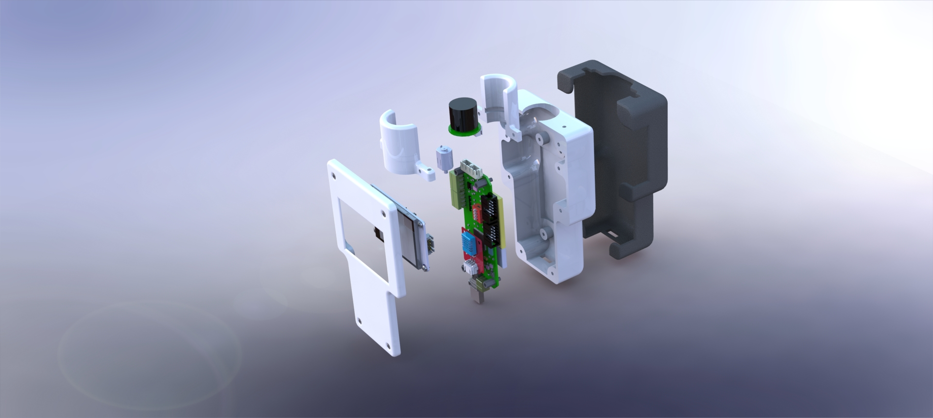

7

4

3

6

5

2

1

Figure 4.1 Disassembly Prototype

Table 6 Disassembly Prototype Parts

|  |  |
| --- | --- |
| 1 | Bezel part A, for covering the Nextion display |
| 2 | Nextion display 320 X 240 |
| 3 | Main PCB using ATmega 2560 as MCU |
| 4 | Battery 1000~3000 mA 3.7 V |
| 5 | Bezel part B, for covering the battery and pcb |
| 6 | Bezel part C, for bottom covering. |
| 7 | Pid sensor |

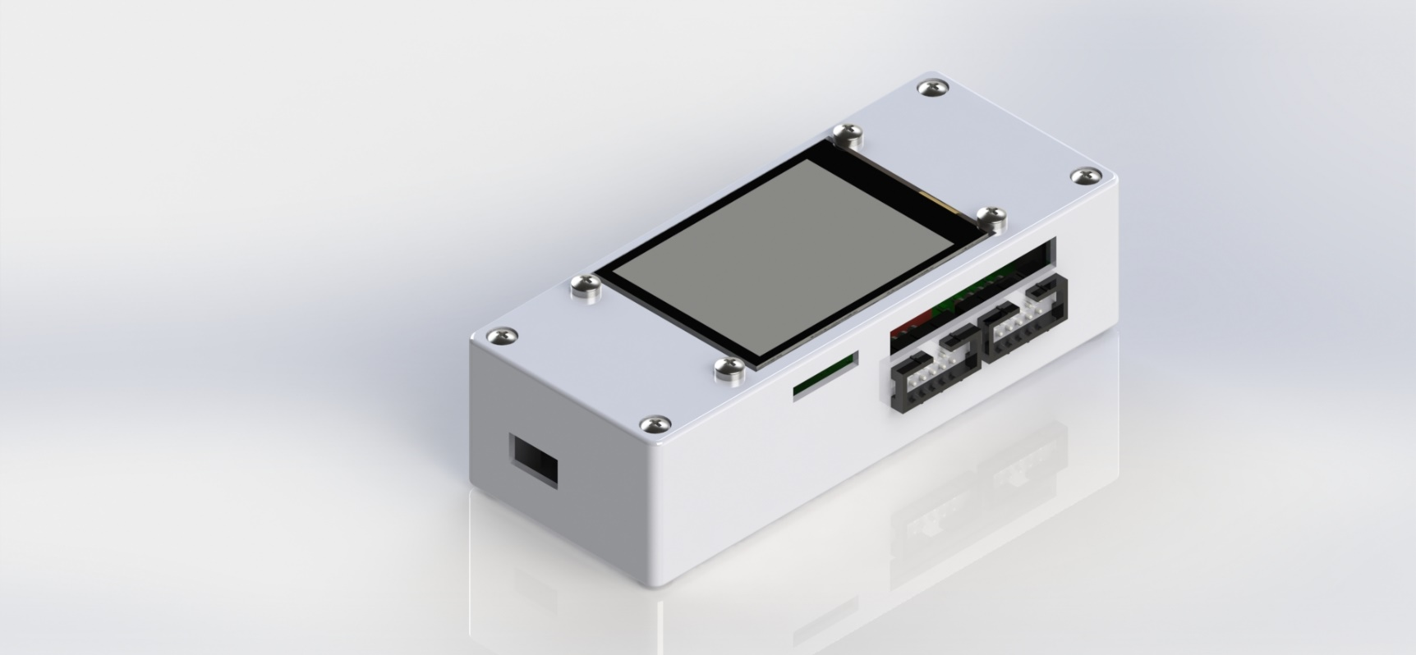

2

4

3

1

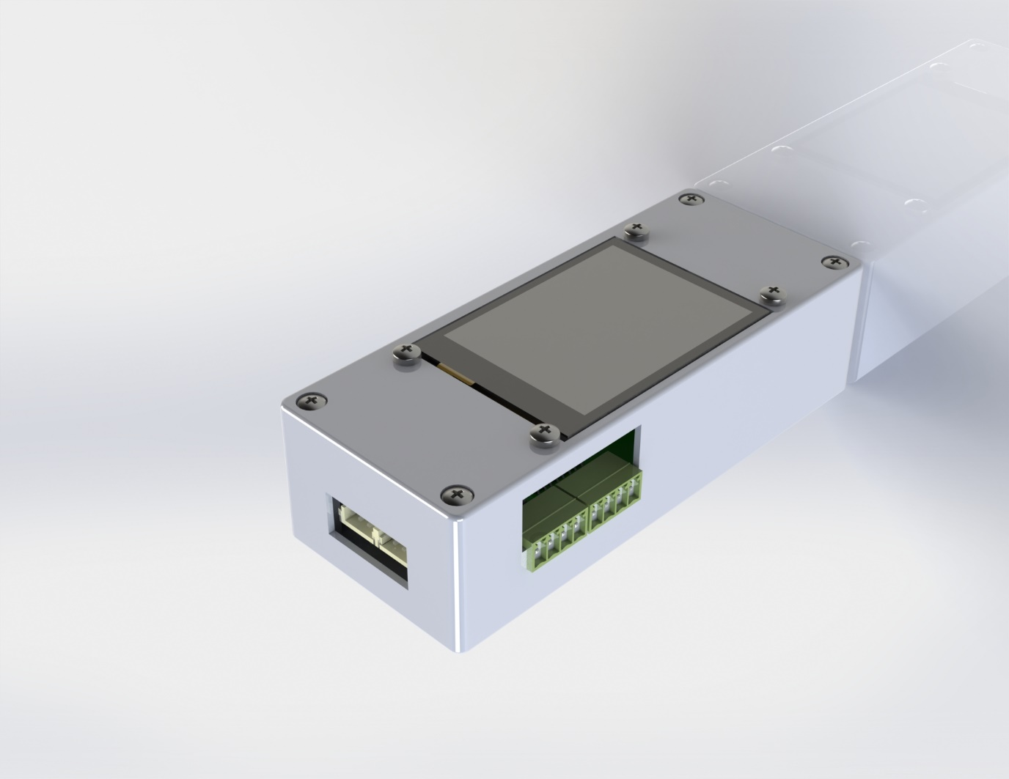

5

6

Figure 4.2 Box PCB

Table 7 PCB Holder (extended edition)

|  |  |
| --- | --- |
| 1 | Input 5 volts to MCU and charging the battery |
| 2 | Port Communication, Serial Communication, I2C communication and SPI communication |
| 3 | NEXTION display resolution 320 X 240 |
| 4 | SD CARD input for HMI interface |
| 5 | Output terminals |
| 6 | Sensor Communication Terminals |



# **Touch Panel**

The touch panel is composed for 14 pages which are going to be detailed below:

## Page 0:

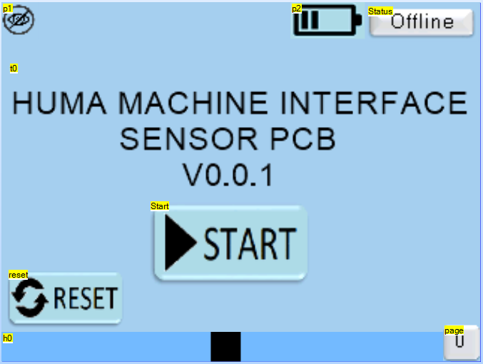

2

6

5

4

3

1

Figure 5.1 Page 0 Nextion Editor

Table 8 Description of HMI of Page 0

|  |  |
| --- | --- |
| 1 | Option to change the page, next page 1. |
| 2 | Tag used for showing the connection with the system is online, activated. Battery status |
| 3 | Button reset, which its function is to reset the MCU memory, furthermore it will move to another page for resetting. |
| 4 | Brightness control from 10% to 100% of intensity |
| 5 | Tag for showing the page which MCU is reading |
| 6 | Led Image to visualize the status of the communication, green means a suitable communication between MCU and Display, red means some fail communication or reset the status. This led will be in most of the pages and their function is the same. |

The principal page has the title of the prototype, two buttons and one graphic alert.

## Page 1

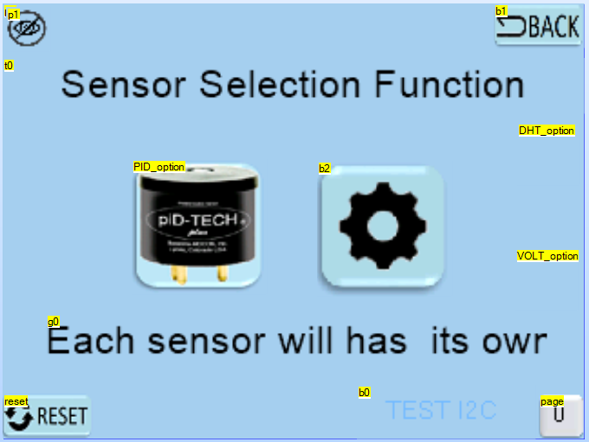

3

4

2

5

8

6

1

7

Figure 5.2 Page 1 Nextion Editor

Table 9 Description of HMI of Page 1

|  |  |
| --- | --- |
| 1 | Led Image to visualize the status of the communication, green means a suitable communication between MCU and Display, red means some fail communication or reset the status. This led will be in most of the pages and their function is the same. |
| 2 | Set Button to access to page 2, page where VOC sensor interface is located |
| 3 | Set Button to access to page 5, page where DHT11/22 sensor interface is located |
| 4 | Set Button to access to page 8, page where Extra Input sensor interface is located |
| 5 | Set Button to test I2C communication by using a small oled LCD |
| 6 | Reset button will sent a command line to refresh the page, it is important when the page is facing some communication issues, this reset button will be in most of the pages and their function is the same. |
| 7 | Home button, it provides the option to return to the previous page, this home button will be in most of the pages and their function is the same. |
| 8 | Tag for showing the page which MCU is reading, this tag will be in most of the pages and their function is the same. |

## 

## Page 2

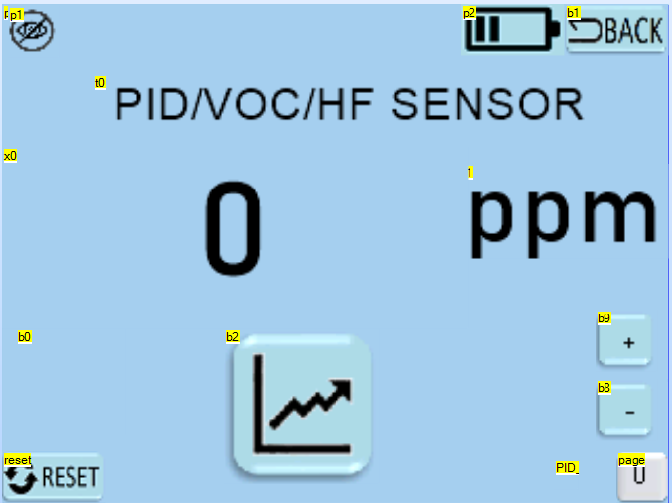

2

7

6

5

4

3

1

Figure 5.3 Page 2 Nextion Editor

Table 10 Description of HMI of Page 2

|  |  |
| --- | --- |
| 1 | Led Image to visualize the status of the communication, green means a suitable communication between MCU and Display, red means some fail communication or reset the status. |
| 2 | Home button, it provides the option to return to the previous page. |
| 3 | Reset button will sent a command line to refresh the page, it is important when the page is facing some communication issues. |
| 4 | Tag for showing the page which MCU is reading. |
| 5 | Label tag for the sensor, this case for VOC |
| 6 | Button Line Graphs to change the page 4. |
| 7 | Button Calibration ppm ppb. |

## Page 3

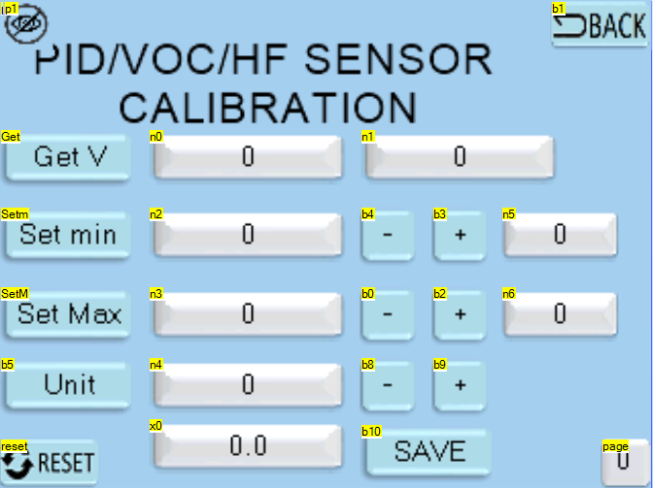

10

9

8

7

6

5

1

2

3

4

Figure 5.4 Page 3 Nextion Editor

Table 11 Description of HMI of Page 3

|  |  |
| --- | --- |
| 1 | Led Image to visualize the status of the communication, green means a suitable communication between MCU and Display, red means some fail communication or reset the status. |
| 2 | Home button, it provides the option to return to the previous page. |
| 3 | Reset button will sent a command line to refresh the page, it is important when the page is facing some communication issues. |
| 4 | Tag for showing the page which MCU is reading. |
| 5 | The Button Get value will take the reading value of the first tag n0, n0 is the value of the sensor 16 bits (65536, -32768 to +32768), n1 is the voltage value in uV |
| 6 | Button Set min value, will take the input value from n2 and will compare with value in n5, in order to set the min value, the buttons for – and + where used to control the set value |
| 7 | Button Set max value, will take the input value from n3 and will compare with value in n6, in order to set the max value, the buttons for – and + where used to control the set value |
| 8 | The unit buttons is a new option, to set values from tens, hundreds and units, |
| 9 | For visualization an option with decimal was create, the final value after the map will be plot in n4 and with decimal numbers in x0 |
| 10 | Button save will collect and register all the parameters inside the internal memory of the ATmega2560. |

## Page 4

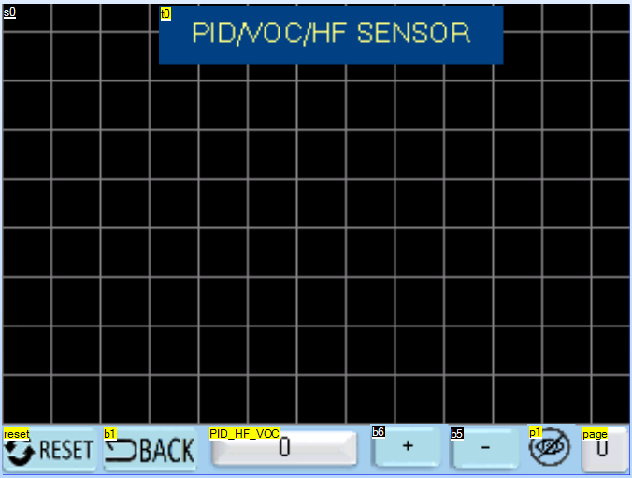

7

6

5

2

1

4

3

Figure 5.5 Page 4 Nextion Editor

Table 12 Description of HMI of Page 4

|  |  |
| --- | --- |
| 1 | Led Image to visualize the status of the communication, green means a suitable communication between MCU and Display, red means some fail communication or reset the status. |
| 2 | BACK button, it provides the option to return to the previous page. |
| 3 | Reset button will sent a command line to refresh the page, it is important when the page is facing some communication issues. |
| 4 | Tag for showing the page which MCU is reading. |
| 5 | piD tag, this tag will show the value in volts of the sensor. |
| 6 | - And + Buttons to control the resolution of the graphs. |
| 7 | Graphs to plot the behavior of the sensor during the working time. |

## Page 5(option available in second version)

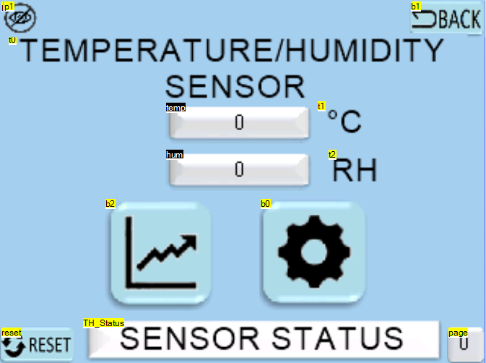

7

8

5

6

1

2

3

4

Figure 5.6 Page 5 Nextion Editor

Table 13 Description of HMI of Page 5

|  |  |
| --- | --- |
| 1 | Led Image to visualize the status of the communication, green means a suitable communication between MCU and Display, red means some fail communication or reset the status. |
| 2 | Home button, it provides the option to return to the previous page. |
| 3 | Reset button will sent a command line to refresh the page, it is important when the page is facing some communication issues. |
| 4 | Tag for showing the page which MCU is reading. |
| 5 | These tags will show the current value of temperature and humidity (sampling time 1250 mm) |
| 6 | Button Line Graphs to change the page 7. |
| 7 | Button Calibration to change the page 6. |
| 8 | Text block describes the ideal working status of the sensor, “online” or “offline” |

## Page 6(option available in second version)

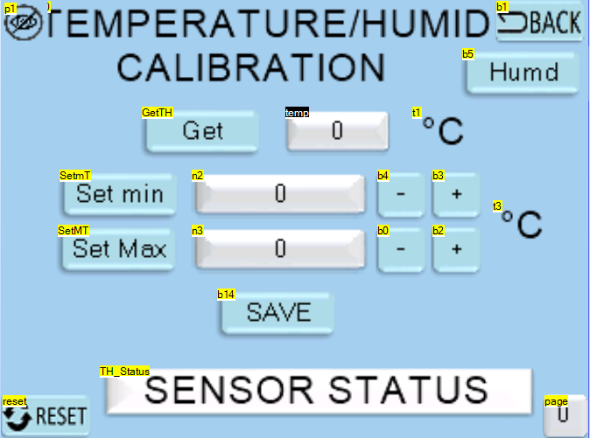

10

9

8

7

6

5

1

2

3

4

Figure 5.7 Page 6 Nextion Editor

Table 14 Description of HMI of Page 6

|  |  |
| --- | --- |
| 1 | Led Image to visualize the status of the communication, green means a suitable communication between MCU and Display, red means some fail communication or reset the status. |
| 2 | Home button, it provides the option to return to the previous page. |
| 3 | Reset button will sent a command line to refresh the page, it is important when the page is facing some communication issues. |
| 4 | Tag for showing the page which MCU is reading. |
| 5 | “Get” button to stop the sampling time and get the temperature of the environment. |
| 6 | Button Set min, this option will provide the safety of the board, boundaries to control the temperature of the environment. Minimal temperature for working. |
| 7 | Button Set Max, this option will provide the safety of the board, boundaries to control the temperature of the environment. Max temperature for working. |
| 8 | Save button has the function collect the data and save in the internal memory. |
| 9 | Text block describes the ideal working status of the sensor, “online” or “offline” |
| 10 | “Humd” Button will move to the page 14 for humidity settings. |

## Page 7(option available in second version)

## 

9

8

5

6

3

2

1

7

4

Figure 5.8 Page 7 Nextion Editor

Table 15 Description of HMI of Page 7

|  |  |
| --- | --- |
| 1 | Led Image to visualize the status of the communication, green means a suitable communication between MCU and Display, red means some fail communication or reset the status. |
| 2 | BACK button, it provides the option to return to the previous page. |
| 3 | Reset button will sent a command line to refresh the page, it is important when the page is facing some communication issues. |
| 4 | Tag for showing the page which MCU is reading. |
| 5 | Temperature and humidity tag, this tag will show the value in Celsius and % humidity of the sensor. |
| 6 | - And + Buttons to control the resolution of the graphs. |
| 7 | Graphic to plot the behavior of the sensor during the working time. |
| 8 | Due to the long sampling time (1250ms) is recommended to use a start signal to run the visualization. |
| 9 | The stop button will pause the sensor function, it will make easier the way to return to the last page. |

## Page 8(option available in second version)

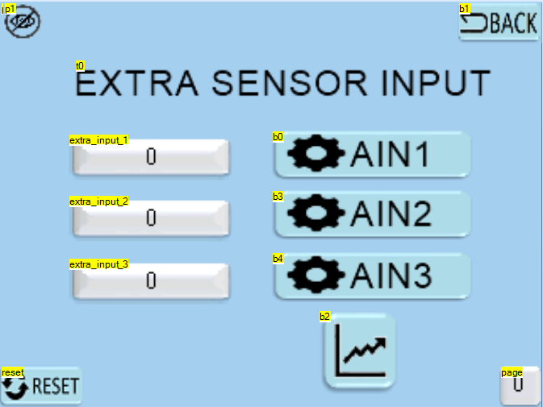

7

6

5

4

3

2

1

Figure 5.9 Page 8 Nextion Editor

Table 16 Description of HMI of Page 8

|  |  |
| --- | --- |
| 1 | Led Image to visualize the status of the communication, green means a suitable communication between MCU and Display, red means some fail communication or reset the status. |
| 2 | Home button, it provides the option to return to the previous page. |
| 3 | Reset button will sent a command line to refresh the page, it is important when the page is facing some communication issues. |
| 4 | Tag for showing the page which MCU is reading. |
| 5 | Label tag for the external input AIN1, AIN2, AIN3 |
| 6 | Button Line Graphs to change the page 12. |
| 7 | Button Calibration to change the page 9, page 10, page 11. |

## Page 9(option available in second version)

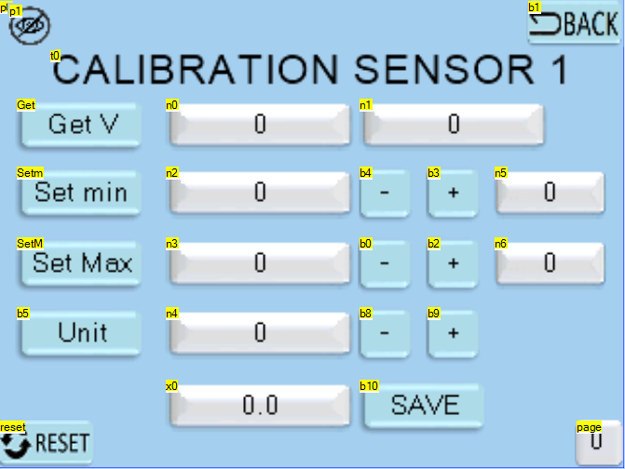

10

9

8

7

6

5

1

2

3

4

Figure 5.10 Page 9 Nextion Editor

Table 17 Description of HMI of Page 9

|  |  |
| --- | --- |
| 1 | Led Image to visualize the status of the communication, green means a suitable communication between MCU and Display, red means some fail communication or reset the status. |
| 2 | Home button, it provides the option to return to the previous page. |
| 3 | Reset button will sent a command line to refresh the page, it is important when the page is facing some communication issues. |
| 4 | Tag for showing the page which MCU is reading. |
| 5 | The Button Get value will take the reading value of the first tag n0, n0 is the value of the sensor 16 bits (65536, -32768 to +32768), n1 is the voltage value in uV |
| 6 | Button Set min value, will take the input value from n2 and will compare with value in n5, in order to set the min value, the buttons for – and + where used to control the set value |
| 7 | Button Set max value, will take the input value from n3 and will compare with value in n6, in order to set the max value, the buttons for – and + where used to control the set value |
| 8 | The unit buttons is a new option, to set values from tens, hundreds and units, |
| 9 | For visualization an option with decimal was create, the final value after the map will be plot in n4 and with decimal numbers in x0 |
| 10 | Button save will collect and register all the parameters inside the internal memory of the ATmega2560. |

## Page 10(option available in second version)

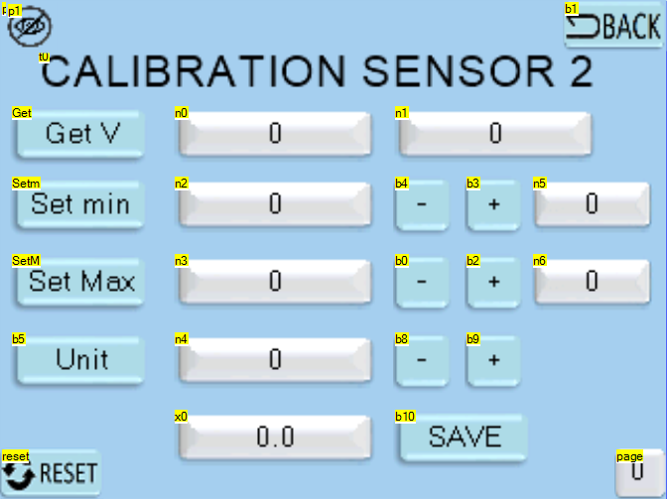

10

8

7

6

5

9

1

2

3

4

Figure 5.11 Page 10 Nextion Editor

Table 18 Description of HMI of Page 10

|  |  |
| --- | --- |
| 1 | Led Image to visualize the status of the communication, green means a suitable communication between MCU and Display, red means some fail communication or reset the status. |
| 2 | Home button, it provides the option to return to the previous page. |
| 3 | Reset button will sent a command line to refresh the page, it is important when the page is facing some communication issues. |
| 4 | Tag for showing the page which MCU is reading. |
| 5 | The Button Get value will take the reading value of the first tag n0, n0 is the value of the sensor 16 bits (65536, -32768 to +32768), n1 is the voltage value in uV |
| 6 | Button Set min value, will take the input value from n2 and will compare with value in n5, in order to set the min value, the buttons for – and + where used to control the set value |
| 7 | Button Set max value, will take the input value from n3 and will compare with value in n6, in order to set the max value, the buttons for – and + where used to control the set value |
| 8 | The unit buttons is a new option, to set values from tens, hundreds and units, |
| 9 | For visualization an option with decimal was create, the final value after the map will be plot in n4 and with decimal numbers in x0 |
| 10 | Button save will collect and register all the parameters inside the internal memory of the ATmega2560. |

## Page 11(option available in second version)

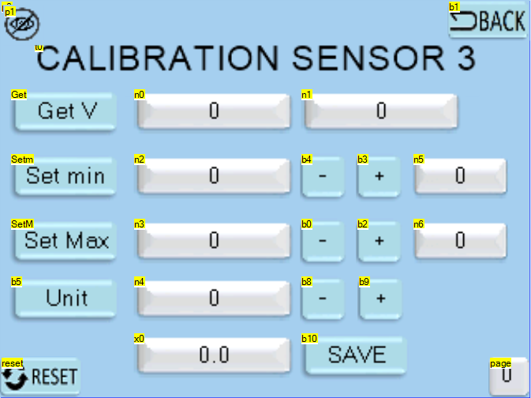

8

7

6

5

10

9

1

2

3

4

Figure 5.12 Page 11 Nextion Editor

Table 19 Description of HMI of Page 11

|  |  |
| --- | --- |
| 1 | Led Image to visualize the status of the communication, green means a suitable communication between MCU and Display, red means some fail communication or reset the status. |
| 2 | Home button, it provides the option to return to the previous page. |
| 3 | Reset button will sent a command line to refresh the page, it is important when the page is facing some communication issues. |
| 4 | Tag for showing the page which MCU is reading. |
| 5 | The Button Get value will take the reading value of the first tag n0, n0 is the value of the sensor 16 bits (65536, -32768 to +32768), n1 is the voltage value in uV |
| 6 | Button Set min value, will take the input value from n2 and will compare with value in n5, in order to set the min value, the buttons for – and + where used to control the set value |
| 7 | Button Set max value, will take the input value from n3 and will compare with value in n6, in order to set the max value, the buttons for – and + where used to control the set value |
| 8 | The unit buttons is a new option, to set values from tens, hundreds and units, |
| 9 | For visualization an option with decimal was create, the final value after the map will be plot in n4 and with decimal numbers in x0 |
| 10 | Button save will collect and register all the parameters inside the internal memory of the ATmega2560. |

## Page 12(option available in second version)

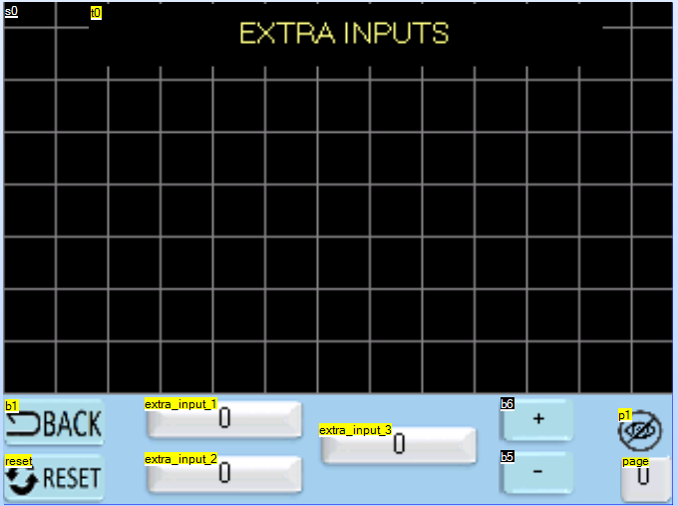

5

6

1

2

7

4

3

Figure 5.13 Page 12 Nextion Editor

Table 20 Description of HMI of Page 12

|  |  |
| --- | --- |
| 1 | Led Image to visualize the status of the communication, green means a suitable communication between MCU and Display, red means some fail communication or reset the status. |
| 2 | BACK button, it provides the option to return to the previous page. |
| 3 | Reset button will sent a command line to refresh the page, it is important when the page is facing some communication issues. |
| 4 | Tag for showing the page which MCU is reading. |
| 5 | Extra analog input AIN1, AIN2 AIN3. |
| 6 | - And + Buttons to control the resolution of the graphs. |
| 7 | Graphs to plot the behavior of the sensor during the working time. |

## Page 13

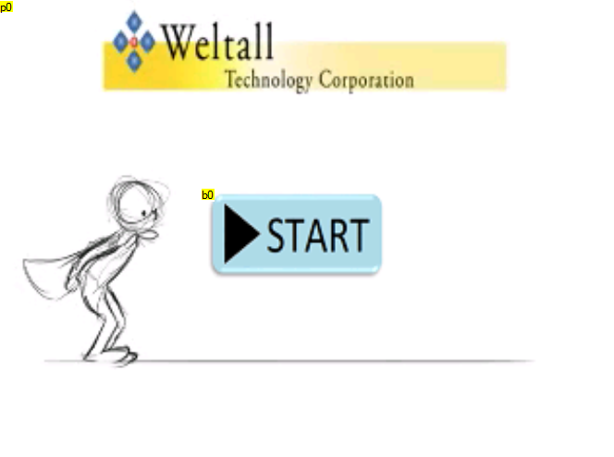

1

Figure 5.14 Page 13 Nextion Editor

Table 21 Description of HMI of Page 13

|  |  |
| --- | --- |
| 1 | Start button for initialize the memory of the ATmega 2560. The default settings are: |
|  | memory.d.M_m1 = -6; Min. Value for sensor 1  memory.d.M_M1 = 6; Max. Value for sensor 1  memory.d.M_m2 = -6; Min. Value for sensor 2  memory.d.M_M2 = 6; Max. Value for sensor 2  memory.d.M_m3 = -6; Min. Value for sensor 3  memory.d.M_M3 = 6; Max. Value for sensor 3  memory.d.M_m4 = -6; Min. Value for sensor 4  memory.d.M_M4 = 6; Max. Value for sensor 4  memory.d.M_Tempm = 20; Min. Value for Temperature  memory.d.M_TempM = 35; Max. Value for Temperature  memory.d.M_Humdm = 45; Min. Value for humidity  memory.d.M_HumdM = 90; Max. Value for humidity  memory.d.M_AIN0m = -32767; Min. Value for mapping sensor 1  memory.d.M_AIN0M = 32767; Max. Value for mapping sensor 1  memory.d.M_AIN1m = -32767; Min. Value for mapping sensor 2  memory.d.M_AIN1M = 32767; Max. Value for mapping sensor 2  memory.d.M_AIN2m = -32767; Min. Value for mapping sensor 3  memory.d.M_AIN2M = 32767; Max. Value for mapping sensor 3  memory.d.M_AIN3m = -32767; Min. Value for mapping sensor 4  memory.d.M_AIN3M = 32767; Max. Value for mapping sensor 4 |

## Page 14(option available in second version)

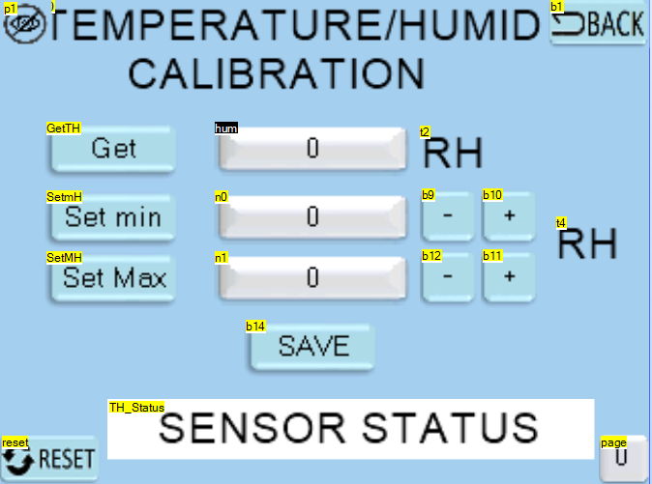

5

6

7

9

8

1

2

3

4

Figure 5.15 Page 14 Nextion Editor

Table 22 Description of HMI of Page 14

|  |  |
| --- | --- |
| 1 | Led Image to visualize the status of the communication, green means a suitable communication between MCU and Display, red means some fail communication or reset the status. |
| 2 | Home button, it provides the option to return to the previous page. |
| 3 | Reset button will sent a command line to refresh the page, it is important when the page is facing some communication issues. |
| 4 | Tag for showing the page which MCU is reading. |
| 5 | “Get” button to stop the sampling time and get the Relative Humidity of the environment. |
| 6 | Button Set min, this option will provide the safety of the board, boundaries parameters to control the humidity of the environment. Minimal % humidity for working. |
| 7 | Button Set Max, this option will provide the safety of the board, temperature boundaries to control the temperature of the environment. Max % humidity for working. |
| 8 | Save button has the function collect the data and save in the internal memory. |
| 9 | Text block describes the ideal working status of the sensor, “online” or “offline” |

Due to memory storage this page was upgraded at the end of the program.



# **Settings**

The first screen shows the options reset the settings or start the program.



Figure 6.1 Nextion Screen Page 0

The next example we are going to set the voltage reading the value of the tag, our system will be an Arduino uno with min voltage 3.3 volts and max voltage of 5 volts.

Connect the sensor and read the value which we are going to read as minimal.

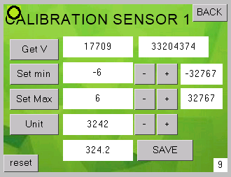

Figure 6.2 Set Min.Voltage of sensor

Then we must to get the value and change our minimal for the new minimal value of the set.

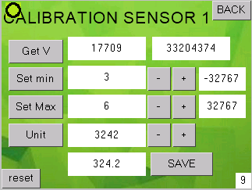

Figure 6.3 Set minimal value

After change our new minimal value we have to press the “Set Min” button to save the new value and send it for mapping in the internal MCU.

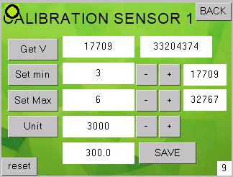

Figure 6.4 Set minimal value visualization

We can see that the new minimal value has changed and we will use this for mapping. Next par we have to do the same with the maximal value, this case 5 volts.

First we read the value of the tag, and press “Get V”.

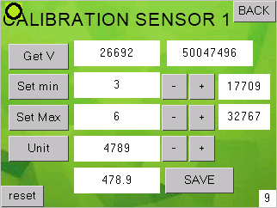

Figure 6.5 Set Maximal value

After change our new maximal value we have to press the “Set Max” button to save the new value and send it for mapping in the internal MCU.

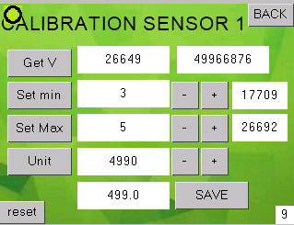

Figure 6.6 Set Maximal value

We can see that the new maximal value has changed and we will use this for mapping. Finally we will see our new mapping value in the last tag.

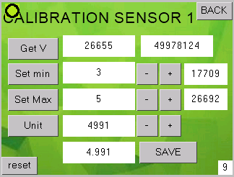

Figure 6.7 The new value after mapping

This methodology will be used for the rest of the external input and for any new sensor in our equipment. For temperature and humidity sensor we just set a minimal and maximal value for alarms or set point for future purposes.

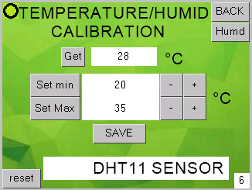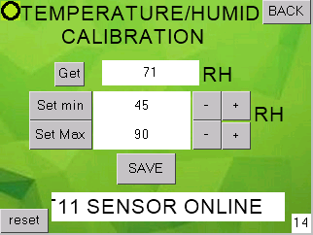

Figure 6.8 DHT SENSOR

Working Cycle to Set Values



# **Attachment**

The next figures are from the second stage of this prototype, where we are going to get some shields to improve the functionality.

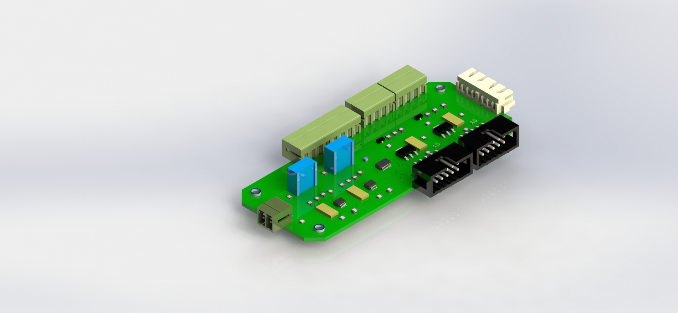

Figure 7.1 IO PCB VERSION 1

. 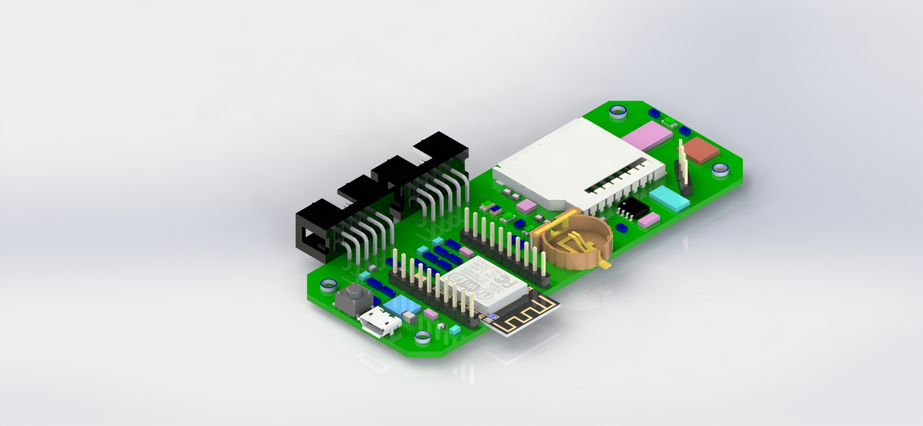

Figure 7.2 Wifi SD Card PCB Version 1

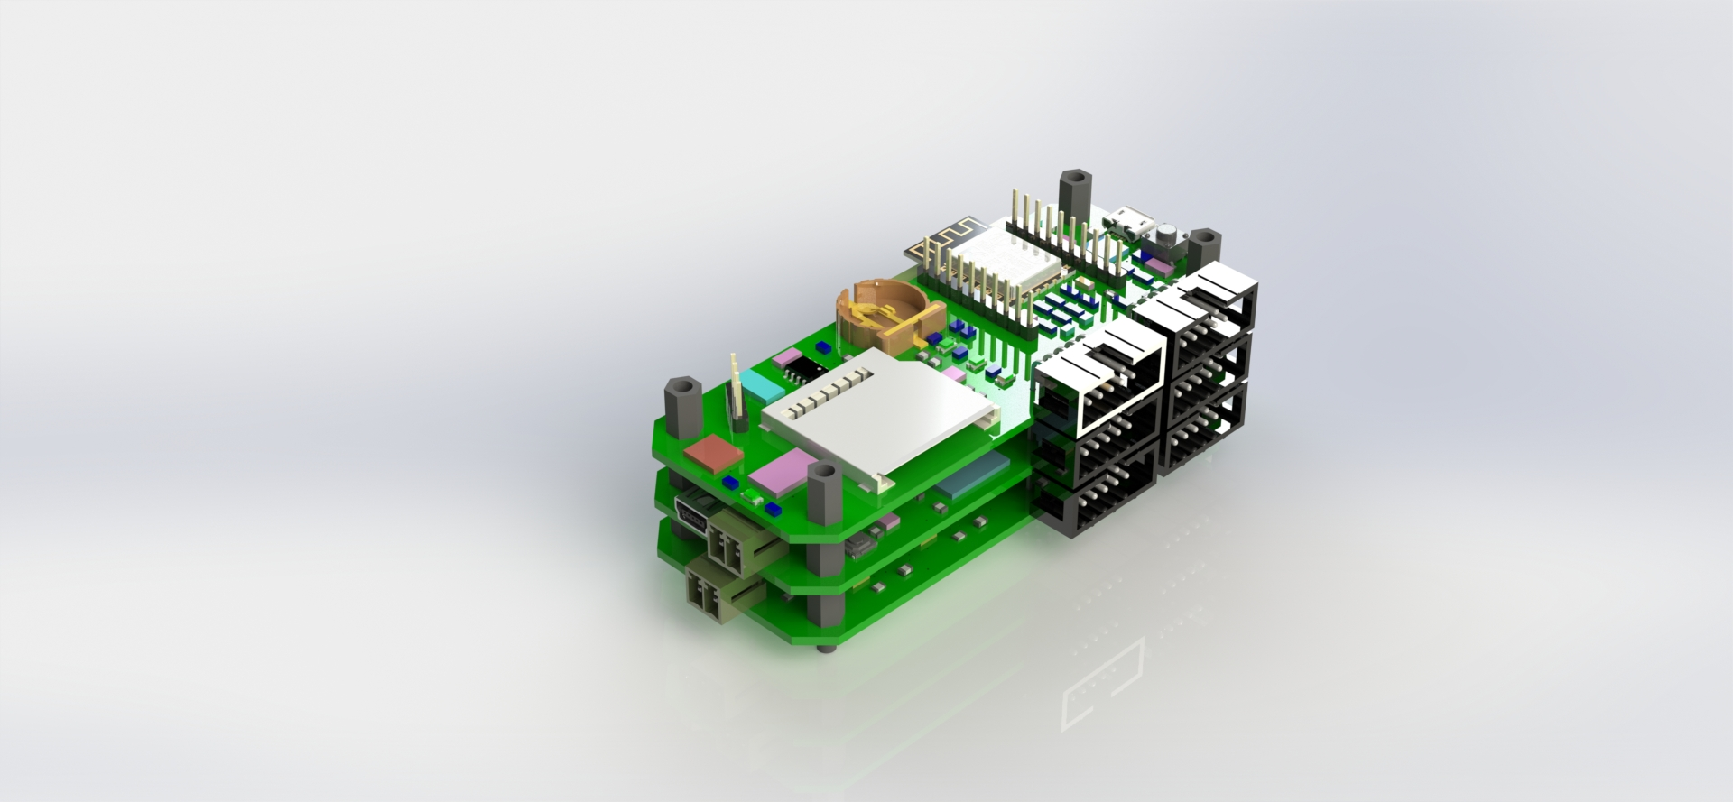

Figure 7.3 Prototype V2

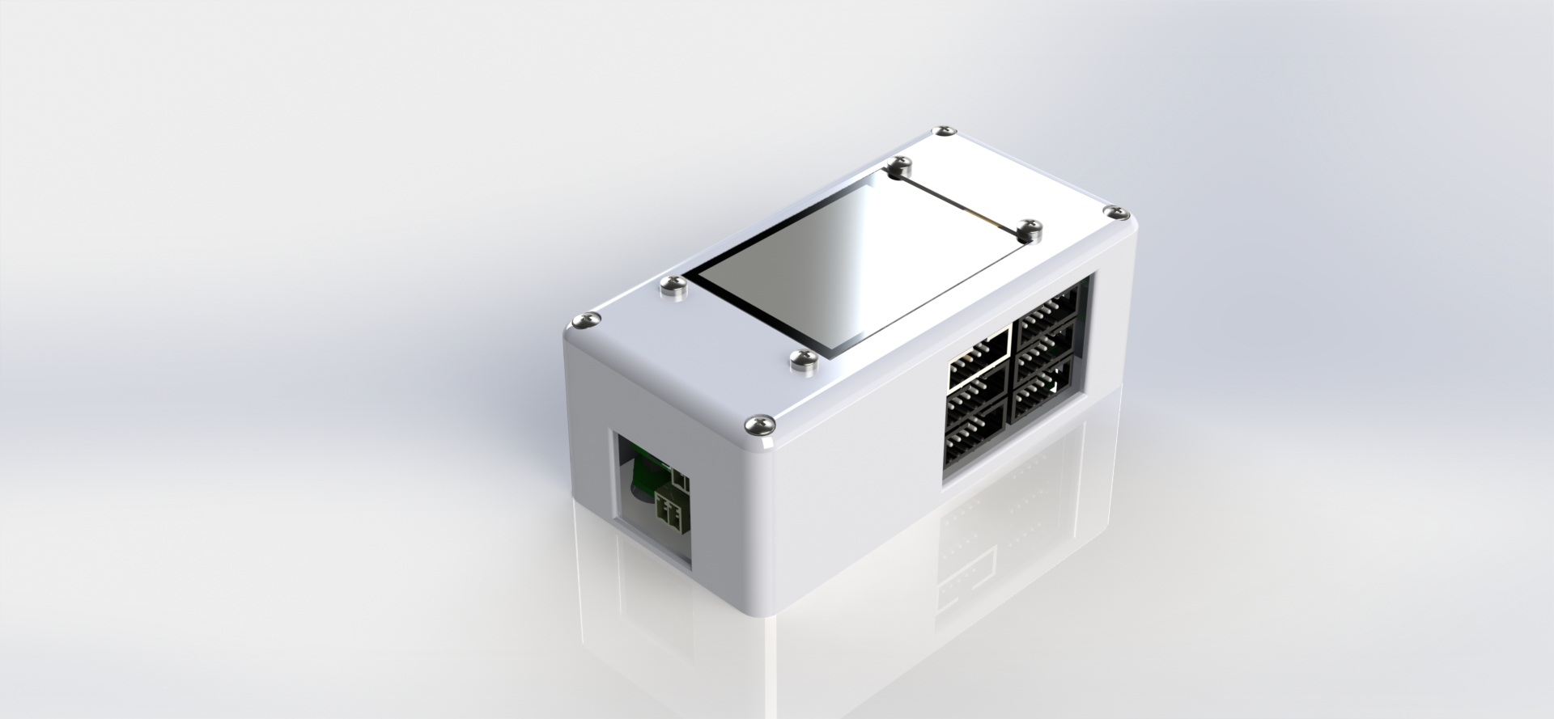

Figure 7.4 Holder Prototype V2



Figure 7.5 Disassembly Prototype v2

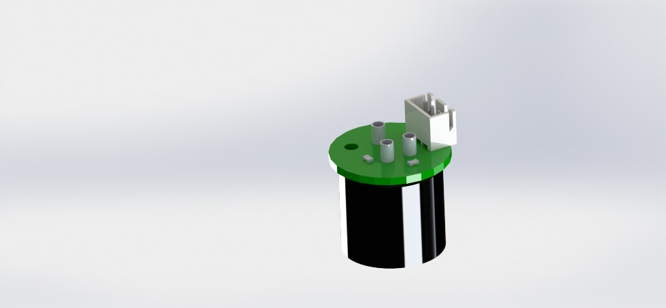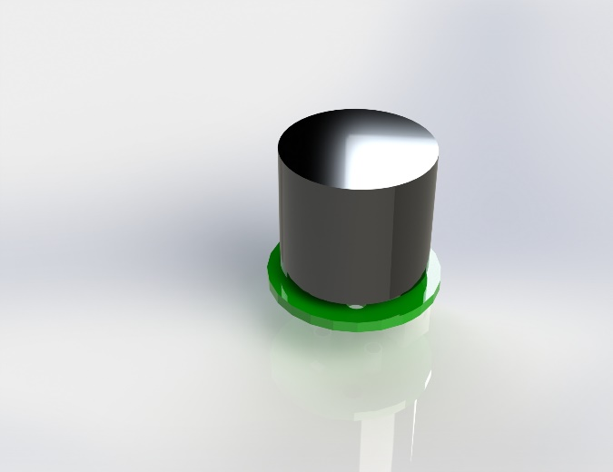

Figure 7.6 piD Sensor Holder